**Escamorid Brona**

**Guard at Keep**

**Fundwisa Finebell**

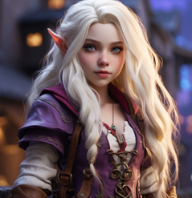

Gang Boss

(The Blackened Coin Syndicate)

**Lady Attanir Valthorien**

**Lord Naadem Valthorien**

